Data : an elementary value
Group items: Data items which have subordinate data items
Record: collection of various data items
File: collection of various records of one type of entity,
Attribute: particular property of an entity
Entity: the class of certain objects.
Field: single elementary unit of information representing the attribute of an entity
DATA STRUCTURE CLASSIFICATION

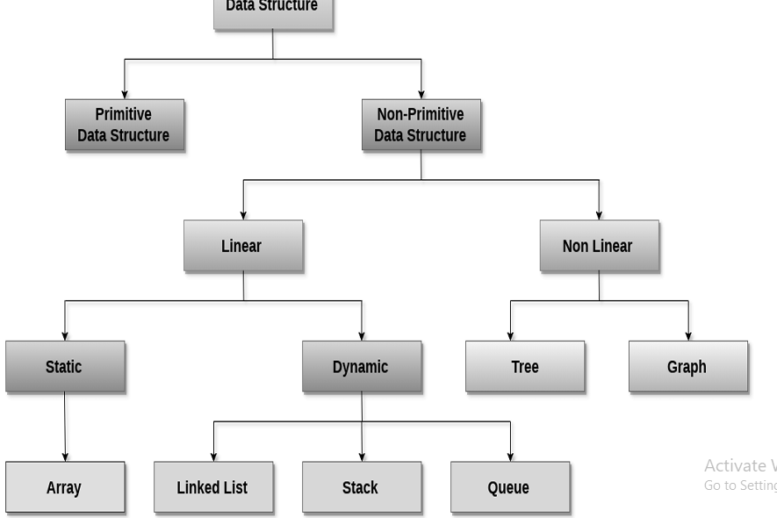
PRIMITIVE DATA STRUCTURES
#include <stdio.h>

int main() {
// Primitive data types in C
int integer = 42;
float floating = 3.14;
char character = 'A';

printf("Primitive Data Types:\n");
printf("Integer: %d\n", integer);
printf("Float: %.2f\n", floating);
printf("Character: %c\n", character);

return 0;
}
How it works
- The program includes the standard input/output library to use printf function for displaying output
- Three primitive variables are declared and initialized: integer (int), floating-point (float), and character (char)
- These are called "primitive" because they are the most basic built-in data types provided by C language
- Each variable stores a single value directly in memory without any complex structure
- The printf statements display each variable’s value using appropriate format specifiers

NON PRIMITIVE DATA STRUCTURES
- STATIC

ARRAYS
#include <stdio.h>

int main() {
// Static Array - fixed size
int numbers[5] = {10, 20, 30, 40, 50};

printf("Array elements:\n");
for(int i = 0; i < 5; i++) {
printf("numbers[%d] = %d\n", i, numbers[i]);
}

return 0;
}
How it works
- An array named "numbers" is declared with fixed size of 5 elements, making it a static data structure
- All five integer values are initialized at compile time within curly braces
- Memory for all 5 elements is allocated contiguously (one after another) when the program starts
- The for loop iterates from index 0 to 4, accessing each element using the index position in square brackets
- This is called "linear" because elements are stored in a sequential line, and "static" because the size cannot change during program execution

- LINEAR DYNAMIC
Linked list
#include <stdio.h>
#include <stdlib.h>

// Node structure
struct Node {
int data;
struct Node* next;
};

// Function to create a new node
struct Node* createNode(int value) {
struct Node* newNode = (struct Node*)malloc(sizeof(struct Node));
newNode->data = value;
newNode->next = NULL;
return newNode;
}

// Function to display linked list
void displayList(struct Node* head) {
struct Node* current = head;
printf("Linked List: ");
while(current != NULL) {
printf("%d -> ", current->data);
current = current->next;
}
printf("NULL\n");
}

int main() {
// Creating nodes
struct Node* head = createNode(10);
struct Node* second = createNode(20);
struct Node* third = createNode(30);

// Linking nodes
head->next = second;
second->next = third;

displayList(head);

return 0;
}
How it works
- The program creates boxes that each hold both a value AND an arrow pointing to the next box
- Unlike an array, these boxes can be anywhere in memory, not necessarily in a straight line
- The arrow (called a pointer) connects the boxes together like a treasure hunt - follow the arrow to find the next box
- You can add new boxes anytime because the program asks for memory when needed
- This is "dynamic" because the chain can grow or shrink while the program run

STACK
#include <stdio.h>
#include <stdlib.h>
#define MAX 5

struct Stack {
int arr[MAX];
int top;
};

// Initialize stack
void initStack(struct Stack* stack) {
stack->top = -1;
}

// Push operation
void push(struct Stack* stack, int value) {
if(stack->top == MAX - 1) {
printf("Stack Overflow!\n");
return;
}
stack->arr[++stack->top] = value;
printf("%d pushed to stack\n", value);
}

// Pop operation
int pop(struct Stack* stack) {
if(stack->top == -1) {
printf("Stack Underflow!\n");
return -1;
}
return stack->arr[stack->top--];
}

// Display stack
void display(struct Stack* stack) {
if(stack->top == -1) {
printf("Stack is empty\n");
return;
}
printf("Stack elements: ");
for(int i = stack->top; i >= 0; i--) {
printf("%d ", stack->arr[i]);
}
printf("\n");
}

int main() {
struct Stack stack;
initStack(&stack);

push(&stack, 10);
push(&stack, 20);
push(&stack, 30);

display(&stack);

printf("Popped: %d\n", pop(&stack));
display(&stack);

return 0;
}
How it works
- The stack uses a top pointer that always indicates the position of the most recently added element
- Push operation first checks for overflow (stack full) before incrementing top and adding the new element
- The stack follows LIFO principle - the last element pushed (highest top index) will be the first one popped
- All operations happen only at one end (the top), making it efficient for recursive algorithm implementation
- The stack can be implemented using either arrays (static) or linked lists (dynamic) while maintaining LIFO behavior

QUEUE
#include <stdio.h>
#include <stdlib.h>
#define MAX 5

struct Queue {
int arr[MAX];
int front, rear;
};

// Initialize queue
void initQueue(struct Queue* queue) {
queue->front = -1;
queue->rear = -1;
}

// Enqueue operation
void enqueue(struct Queue* queue, int value) {
if(queue->rear == MAX - 1) {
printf("Queue Overflow!\n");
return;
}
if(queue->front == -1) {
queue->front = 0;
}
queue->arr[++queue->rear] = value;
printf("%d enqueued to queue\n", value);
}

// Dequeue operation
int dequeue(struct Queue* queue) {
if(queue->front == -1 || queue->front > queue->rear) {
printf("Queue Underflow!\n");
return -1;
}
return queue->arr[queue->front++];
}

// Display queue
void display(struct Queue* queue) {
if(queue->front == -1 || queue->front > queue->rear) {
printf("Queue is empty\n");
return;
}
printf("Queue elements: ");
for(int i = queue->front; i <= queue->rear; i++) {
printf("%d ", queue->arr[i]);
}
printf("\n");
}

int main() {
struct Queue queue;
initQueue(&queue);

enqueue(&queue, 10);
enqueue(&queue, 20);
enqueue(&queue, 30);

display(&queue);

printf("Dequeued: %d\n", dequeue(&queue));
display(&queue);

return 0;
}
How it works
- The queue maintains two pointers: front (for removal) and rear (for insertion), enabling FIFO behavior
- Enqueue operation adds elements at the rear end after checking for overflow condition
- When first element is added, front is set to 0 to mark the beginning of the queue
- Elements are processed in the exact order they arrived - like a real-world queue or waiting line
- Dequeue operation removes elements from the front, ensuring the element that waited longest is served first

- NON LINEAR
TREE
#include <stdio.h>
#include <stdlib.h>

// Tree node structure
struct TreeNode {
int data;
struct TreeNode* left;
struct TreeNode* right;
};

// Create new tree node
struct TreeNode* createNode(int value) {
struct TreeNode* newNode = (struct TreeNode*)malloc(sizeof(struct TreeNode));
newNode->data = value;
newNode->left = NULL;
newNode->right = NULL;
return newNode;
}

// In-order traversal
void inorderTraversal(struct TreeNode* root) {
if(root != NULL) {
inorderTraversal(root->left);
printf("%d ", root->data);
inorderTraversal(root->right);
}
}

int main() {
// Creating a simple binary tree
struct TreeNode* root = createNode(1);
root->left = createNode(2);
root->right = createNode(3);
root->left->left = createNode(4);
root->left->right = createNode(5);

printf("Binary Tree (In-order traversal): ");
inorderTraversal(root);
printf("\n");

return 0;
}
How it works
- Each node contains data and pointers to left and right children, creating a hierarchical parent-child relationship
- The tree is non-linear because data is organized in levels rather than a sequential line
- In-order traversal uses recursion to visit left subtree first, then the current node, then right subtree
- Recursion creates a systematic way to visit all nodes by breaking the tree into smaller subtrees
- The NULL check in the recursive function prevents infinite recursion and handles leaf nodes (nodes with no children)

GRAPH
#include <stdio.h>
#include <stdlib.h>
#define V 5

// Adjacency matrix representation
void addEdge(int graph[V][V], int u, int v) {
graph[u][v] = 1;
graph[v][u] = 1; // For undirected graph
}

// Display graph
void displayGraph(int graph[V][V]) {
printf("Adjacency Matrix:\n");
for(int i = 0; i < V; i++) {
for(int j = 0; j < V; j++) {
printf("%d ", graph[i][j]);
}
printf("\n");
}
}

int main() {
// Initialize graph with zeros
int graph[V][V] = {0};

// Adding edges
addEdge(graph, 0, 1);
addEdge(graph, 0, 2);
addEdge(graph, 1, 2);
addEdge(graph, 1, 3);
addEdge(graph, 2, 4);

displayGraph(graph);

return 0;
}
How it works
- Imagine a map of cities - the cities are points (vertices) and roads between them are connections (edges)
- The program uses a big grid or table to remember which cities are connected to each other
- If city 0 and city 1 are connected, the program puts a "1" in the box where row 0 meets column 1
- For roads that go both ways, it puts a "1" in two boxes - [0][1] and [1][0]
- This is "non-linear" because cities can connect in any pattern - you can have loops, multiple connections, or no connections at all
- Imagine a map of cities - the cities are points (vertices) and roads between them are connections (edges)
- s a big grid or table to remember which cities are connected to each other
- If city 0 and city 1 are connected, the program puts a "1" in the box where row 0 meets column 1
- For roads that go both ways, it puts a "1" in two boxes - [0][1] and [1][0]
- This is "non-linear" because cities can connect in any pattern - you can have loops, multiple connections, or no connections at all

